

Formative Exam
Teacher : Candice Henriquez

======================================================

ANSWER SHEET
ECONOMICS
Your Name: _________________________

Question # | Answer | Question # | Answer
1 | A | 11
2 | C | 12
3 | C | 13
4 | C | 14
5 | D | 15
6 | C | 16
7 | C | 17
8 | B
9
10

Multiple choice questions

- If the demand and supply curves for good “Z” are
Qd = 24 - 2P
Qs = 6 + P
The market will be in equilibrium if

- P = 6 and Q = 12
- P = 10 and Q = 16
- P = 12 and Q = 6
- P = 16 and Q = 10

- The figure below shows the market supply and demand curves for cigarettes.

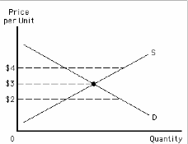

If the government sets a minimum price of $4,
- the market will be in equilibrium
- there will be a shortage of cigarettes
- there will be excess supply of cigarettes
- the quality of good X will improve

- According to the law of demand,
- the quantity supplied of a good rises when the price of the good rises
- the quantity supplied of a good falls when the price of the good rises
- the quantity demanded of a good falls when the price of the good rises
- the quantity demanded of a good rises when the price of the good rises

- Which of the following shifts the market demand curve to the right?
- An increase in the labor costs
- New technology
- An increase of the population
- A decrease of the consumer income

- Refer to the table below.
Price | Quantity demanded | Quantity supplied
$10 | 50 | 20
$15 | 45 | 30
$20 | 40 | 40
$25 | 35 | 50
$30 | 30 | 60

Which of the following is true?
- The market is in equilibrium when the price is $25.
- There is a surplus in the market when the price is $10.
- The market is in equilibrium when the price is $30.
- There is a shortage in the market when the price is $15.

- When Jenny’s income increases, her demand curve for hotdogs shifts to the left. To Jenny, hotdog is
- a normal good
- a luxury
- an inferior good
- a complementary good

- Which of the following will cause a movement along the demand curve?
- A change in the income
- A change in the consumer tastes
- A change in the price of the good
- A change in the price of a substitute of the good

- Strawberries and blueberries are considered substitutes. An increase in the price of strawberries will result in
- An increase in the demand for strawberries
- An increase in the demand for blueberries
- A decrease in the demand for both strawberries and blueberries
- A decrease in the supply of both strawberries and blueberries

- Which of the following is NOT a characteristic of a market with perfect competition:
- Buyers and sellers are price takers
- Products are the same
- Numerous buyers and sellers
- The products are slightly differentiated
  - Characteristic of monopolistic

- A market with many sellers but each seller may set the price for its own product is called
- Perfect competition
- Monopolistic competition
- Oligopoly
- Monopoly
- Lisa uses her income of NAf.25 to buy magazines and smoothies. The price of a magazine is NAf.10 and the price of a smoothie is NAf.5. If the price of a smoothie changes to NAf.6,
- Lisa’s budget constraint line shifts to the right without a change in the slope
- Lisa’s budget constraint line shifts to the left without a change in the slope
- Lisa’s budget constraint line rotates inward and changes the slope of the budget constraint line
- Lisa’s budget constraint line rotates outward and changes the slope of the budget constraint line

- If an increase in the income by 4% results in an increase in the demand for good X by 6%, then good X is
- an inferior good
- a luxury
- a complement
- a necessity
- The cross-price elasticity of demand between good A and good B is -0.3. Good A and good B are
- Substitutes
- Inferior goods
- Complements
- Luxury goods
- The price elasticity of demand for good X is -5. If the price of good X increases by 2%,
- The demand for good X increases by 0.4%
- The demand for good X decreases by 0.4%
- The demand for good X increases by 10.0%
- The demand for good X decreases by 10.0%
x/2% = -5
-5 x 2% = =10%
- The figure below shows Peter’s budget constraint line. The two goods are CDs and magazines.

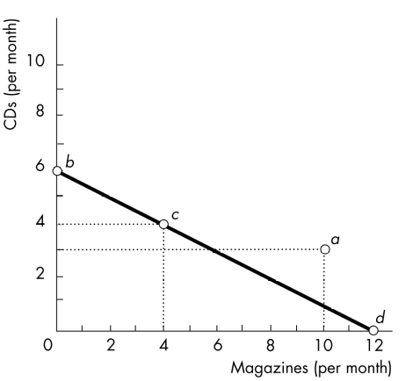
Which combinations of CDs and magazines are NOT affordable to Peter?
- Combination a
- Combination b
- Combination c
- Both combination c and d

- Terry has an income of NAf.100. The figure below shows his budget constraint line.
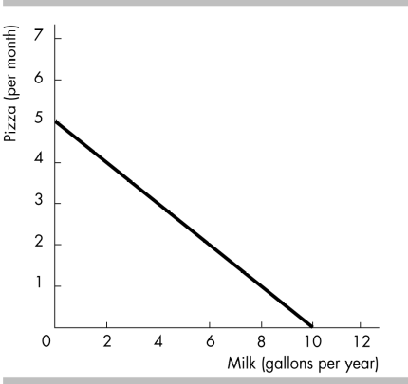

What is the slope of Terry’s budget constraint line?
- -0.5
- 0.5
- 2
- -2
- Consider the figure below:
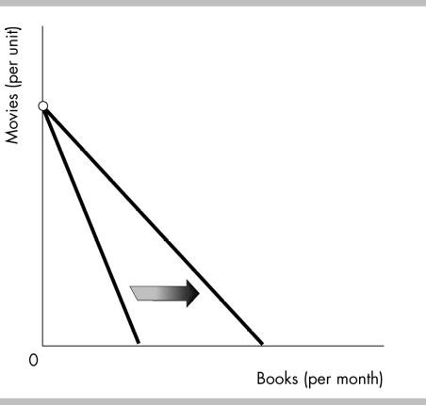

The budget constraint line will rotate in the direction indicated if
- The price of books decreases
- The price of books increases
- The price of movies decreases
- The price of movies increases

